Sepsis Cases – Case 2
Summary of Case Scenario:

A 45 year old man with a history of colon cancer, undergoing chemotherapy, presents with febrile neutropenia and septic shock due to a catheter-related bloodstream infection from a PICC line. He develops worsened hemodynamic instability, obtundation and respiratory failure during his assessment, requiring mechanical ventilation and vasopressor support.

Equipment Setup & Moulage:

- Male patient upright in hospital gown on gurney, head of be elevated
- Connected to cardiac monitor, NIBP cuff, oxygen saturation probe
- Double-lumen PICC line taped to inner aspect right arm above elbow, some surrounding redness at insertion site.
- Standard Resuscitation Equipment and a LTV ventilator available.

Participant Roles:

- Physician team leader
- 2nd physician
- Nurses x 2 (will need earpieces)
- Respiratory therapist
- Family member

Mannequin Programming:

Parameter | Initial Setting | After 5 min | Post-Intubation
HR | 115 | 130 | 125
BP | 95/50 | 80/40 | 75/30
RR | 16 | 20 and shallow | Zero (ventilated)
Saturation | 96% | 91% | 94%
Temp | 38.9 | 39.2 | 39.4
Eye Opening | 15 Blinks/min | Spontaneously | Closed

Case Progression:

Initially, patient is awake, talking, but drowsy. During the initial assessment, he will become more drowsy, less responsive and be working harder to breathe. A fluid bolus will not improve his blood pressure significantly in the first few minutes, and he will become more hypotensive. Additional fluids will transiently increase his BP, but he will become more somnolent and start to desaturate, requiring intubation and ventilation. Post-intubation, he will require a norepinephrine infusion to improve BP, if not already initiated, and will quickly reach a maximal dose.

Case Stem (Provided to Participants)

EMS has just brought this 45 year old man to your ED with a chief complaint of general malaise and fever/chills.

Information for Family Member

He has a history of colon cancer, and had his last chemotherapy about 9 days ago. He had his PICC line inserted about one month earlier, and it’s been working fine. He was doing well up until yesterday, when he became more lethargic and tired, with decreased appetite. He’s just wanted to lie around in bed for most of the last day, and you called EMS today because he seemed more confused and had a temperature.

Meds:

-Ondansetron 4mg q4h prn
-Ranitidine 150mg BID
-Effexor XR 150mg once daily
-no known allergies

Laboratory Results

VBG

pH 7.14
pO₂ 40
pCO₂ 28
HCO₃ 10
ScvO₂ 0.74

CBC

WBC 0.8 (neutrophils 0.1)
Hgb 88
Plt 75

Coags

INR 1.8
PTT 39

Chemistry

Na 132
Cl 97
K 3.5
CO₂ 11
Glucose 7.5
Creat 115
BUN 9.5
CK 97
TnI 0.021
Lactate 5.2

CXR

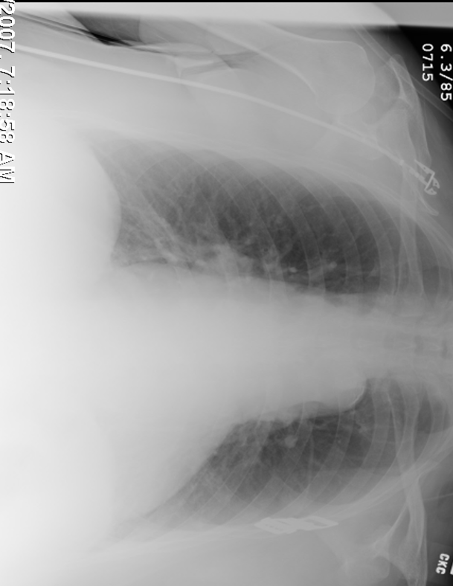

ECG

