Top of Form

Queen’s University Simulation Scenario Template

Course: | SR Rounds: Tox II
Case Title: | Hydrofluoric Acid Burns
Brief Case Description

A 37 year old man comes to the ED with severe pain in his right arm after using some rust remover at home (10% HF). He subsequently suffers a Torsades des Pointes cardiac arrest due to hypocalcemia and hypomagnesemia.
Subcutaneous calcium gluconate, IV calcium gluconate, and overdrive pacing are required to successfully resuscitate this patient
Searchable Keywords:
- Hydrofluoric Acid
- Hypocalcemia
- Torsades des Pointes
Target Audience: | SR’s
Number of Participants: | 5
CanMeds Roles : |  | Medical Expert |  | Manager |  | Scholar
 |  | Communicator |  | Collaborator |  | Professional
 |  | Health Advocate
Objectives:
- Knowledge | Manage the local and systemic toxicities of HF acid poisoning
- Skills | Overdrive Pacing  SC Injection of calcium gluconate  Intra-arterial infusion of calcium gluconate
- Behaviour

Bottom of Form

Stem: Detailed description of exercise
Corey MacIntosh is a 37 year old man who was using a rust removing compound to remove some rust from his lawn mower. He accidently spilled this solution onto his hand and forearm. The solution is 10% Hydrofluoric acid.
He has mild cutaneous burns to his forearm, but his pain is significantly more severe that would be expected from the physical exam. The residents should recognize this as HF burns and immediately apply calcium gluconate jelly to the affected area and/or inject calcium gluconate (0.5 cc of 10% calcium gluconate per 1 cm2).
This improves the pain, but fails to alleviate the systemic toxicity. HF dissociates in the tissue. H+ produces local burns, and the F- chelates Ca2+, and results in systemic hypocalcemia, hypomagnesemia, and hyperkalemia. He is found to have these electrolyte abnormalities, and a long QT on his ECG.
He suffers a cardiac arrest due to Torsades des Pointes. IV MgSO4 and IV CaCl2 is required for the resuscitation to be successful, and they will also be required to overdrive pace the patient.
Roles:
Script (for each role)

Scenario Tips:
- Tips to future instructors to keep the scenario flowing.
- Anticipated difficulties

Scenario Details:
Demographics:  - Name:  - Age:  - Sex:  - BMI | Corey MacIntosh  37  Male
Chief Complaint: | Arm and hand pain after spilling rust remover (10% HF) onto his arm and hand
Past Medical History: | None
Medications: | None
Allergies: | Penicillin
Lab data: (provided if requested) | See Lab sheet: Hypocalcemia, Hypomagnesemia, Hyperkalemia
Imaging: (provided if requested) | N/A
ECG:  (provided if requested) | NSR with Long QT

Initial Physical Examination Findings: (Normal if left blank)
Vital signs:
Temperature | 37.1
HR | 122
BP | 134/80
RR | 20
O₂ saturation | 100
Finger stick glucose | 8.5
Weight (kg) | 82
Cardiovascular:
Heart rate/rhythm | Sinus Tachy
Heart sounds | Normal
JVP | Normal
Peripheral pulses | Normal
Evidence of cyanosis? | No
Diaphoresis | No
Other
Respiratory:
Respiratory rate/pattern | Normal
Accessory muscle use? | Normal
Lung sounds | Normal
Evidence of fatigue? | No
Other
Abdominal:
Visible signs of pathology? | No
Bowel sounds | No
Peritoneal signs? | No
Tenderness? | No
Hepatosplenomegaly? | No
Signs of ascites?
Other
Neurological:
Level of consciousness & Behaviour | Normal: Severe arm and hand pain
Muscle tone
Motor
Sensory
Reflexes
Other
Head/Ears/Eyes/Nose/Throat/Skin:
Visible abnormalities

Flow Table:
Time or Stage: | 0:00 | 2 min after SC Injections | After Defib | Recurrent Torsades | After MgSO4, CaCl2 and Overdrive Pacing
Heart rhythm: | Sinus | Torsades | Sinus | Torsades | Paced
Heart rate: | 122 |  | 130 | 0 | 100
Heart Sounds: | Normal |  |  | 0
Blood pressure: | 134/80 | 0 | 90/60 | 0 | 76/30
Respiratory rate: | 20 | 0 |  | 0 | Vent
Respiratory Pattern: | Normal | Absent | Normal | 0 | Vent
O₂ saturation: | 100 RA | 0 | 93 | 0 | 90
Temperature: | 37.1 |  |  | 0
Glucose | 8.5 |  |  | 0
Eyes: | Open | Closed | Closed | Closed | Closed
Pupils: | Normal
Specific simulator dialogue: | Pain
Other:

Flow Diagram:
Insert specific scenario flow diagram showing pathways for anticipated actions. Each section of the diagram should correspond to a column on the Flow Table above.
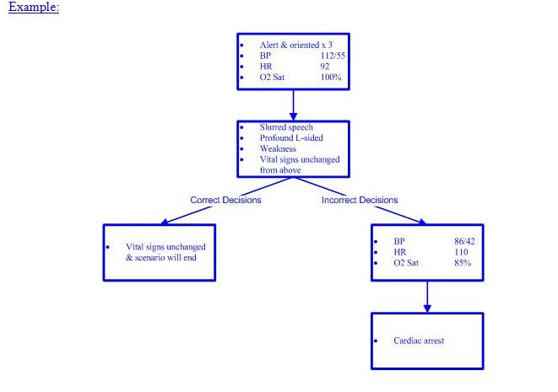

Simulator Requirements:
Environment: |  | ER
 |  | Hospital Ward
 |  | ICU
 |  | Other
Required simulator capabilities: |  | Adult
 |  | Child
 |  | Ability to talk
 |  | Ability to open and close eyes
 |  | Ability to change pupil size
 |  | Output of basic cardiorespiratory rhythms
 |  | Ability to change vital signs
 |  | Ability to perform CPR
 |  | Ability to deliver energy via LifePack
 |  | Ability to gain IV access
 |  | Ability to gain IO access
 |  | Ability to get 12 and 15 lead EKG’s
 |  | Ability to deliver drugs
 |  | Ability to ventilate
 |  | Ability to intubate
 |  | Ability to catheterize
 |  | Ability to needle decompress
 |  | Ability to insert chest tube
 |  | Ability to seize
 |  | Ability to simulate cyanosis
 |  | Other:
Task trainers required: |  | IV access trainer
 |  | IO access trainer
 |  | Lumbar puncture trainer
 |  | Central line access trainer (IJ, femoral, subclavian)
 |  | Chest tube trainer
 |  | Cricothyrotomy trainer
 |  | Pericardiocentesis trainer
 |  | Thoracotomy trainer
 |  | Other:
Communications Equipment: |  | One way wireless (confederate)
 |  | Two way wireless (confederate)
 |  | Overhead Speakers
 |  | Telephone
 |  | Pager
 |  | Other:

Moulage:

Describe any scenario-specific moulage on the diagram below:

Red Burn Marks to right hand and forearm

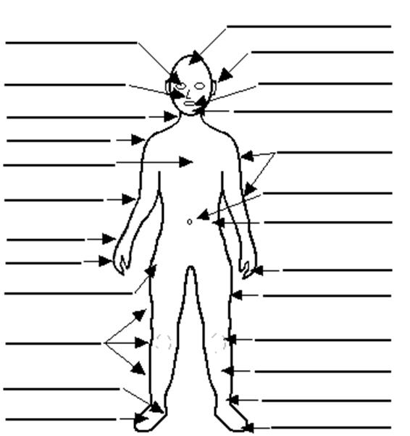

Mannequin Clothing

Hospital gown
Formal work attire
Casual attire
Athletic clothing
Other:

Equipment Required: |  |  |  |  |  | Quantity Required |  | Sizes Required  (if applicable)
Diagnostic/Monitoring: |  |  |  | Portable monitor
 |  |  |  | Thermometer
 |  |  |  | NIBP
 |  |  |  | Defibrillator
 |  |  |  | EKG
 |  |  |  | CXR
 |  |  |  | O₂ saturation probe
Airway: |  |  |  | Bag valve mask
 |  |  |  | Peak flow meter
 |  |  |  | Nasal cannula
 |  |  |  | Nebulizer
 |  |  |  | Non-rebreather mask
 |  |  |  | Mechanical ventilator
 |  |  |  | Oropharyngeal airway
 |  |  |  | Nasopharyngeal airway
 |  |  |  | Non-invasive positive pressure ventilation
 |  |  |  | Laryngoscope
 |  |  |  | Endotracheal tube
 |  |  |  | Syringe
 |  |  |  | Stylet
 |  |  |  | End tidal CO₂ detector (colorimetric)
 |  |  |  | End tidal CO₂ detector (capnographic)
 |  |  |  | Bougie
 |  |  |  | Glidescope
Vascular access: |  |  |  | Peripheral IV
 |  |  |  | Arterial line
 |  |  |  | Central line
 |  |  |  | PICC line
 |  |  |  | Swan Ganz catheter
 |  |  |  | Dialysis catheter
Resuscitation: |  |  |  | Crash cart
 |  |  |  | Trauma cart
 |  |  |  | Difficult airway cart
 |  |  |  | Cricothyrotomy tray
 |  |  |  | Chest tube tray
 |  |  |  | Pericardiocentesis tray
 |  |  |  | Chest tube tray
 |  |  |  | Urinary catheter tray
Other:
Fluids and Drugs |  |  |  |  | Volume, Concentration or Dose Required |  | Number of Units Required
IV Fluids: |  |  | NS
 |  |  | 0.45% NS
 |  |  | 3% NS
 |  |  | 2/3 1/3 NS
 |  |  | D5W
 |  |  | D5 ½ NS
 |  |  | Ringer’s lactate
 |  |  | Pentaspan
 |  |  | Other:
Blood products: |  |  | 25% albumin
 |  |  | 5% albumin
 |  |  | pRBC’s
 |  |  | Platelets
 |  |  | Fresh Frozen Plasma
 |  |  | Cryoprecipitate
 |  |  | Factor VIII concentrate
 |  |  | Factor IX concentrate
 |  |  | Other:
Pre-filled drugs: |  |  | D50W
 |  |  | Epinephrine
 |  |  | Bicarbonate
 |  |  | Calcium chloride
 |  |  | Lidocaine
 |  |  | Atropine
 |  |  | Adenosine
 |  |  | Other: Calcium Gluconate 10% |  | 100 mL |  | 3
Other drugs: |  |  | Fentanyl
 |  |  | Midazolam
 |  |  | Propofol
 |  |  | Etomidate
 |  |  | Ketamine
 |  |  | Succinylcholine
 |  |  | Roccuronium
 |  |  | Glucagon
 |  |  | Digoxin
 |  |  | Lasix
 |  |  | Nitrogylcerin
 |  |  | Labetelol
 |  |  | Other:

Audiovisual Needs:
Imaging: | (link to x-rays, CT scans, ultrasounds, MRI’s)
Bloodwork: | (link to bloodwork here)
EKG’s: | (link to EKG’s here)
Short didactic presentation: | (link to short presentation here – max 5 minutes)
Handouts: | (link to handouts here)
Simulator exercise file: | (link to simulator exercise file here)
References:
Required reading: | (link to required reading here)

Debriefing points:
- Knowledge | Link from objectives
- Skills | Link from objectives
- Behaviour | Link from objectives

Assessment:
- Knowledge  - Objective 1  - Objective 2  - Objective 3 | 1  1  1 | 2  2  2 | 3  3  3 | 4  4  4 | 5  5  5
- Psychomotor  - Objective 1  - Objective 2  - Objective 3 | 1  1  1 | 2  2  2 | 3  3  3 | 4  4  4 | 5  5  5
- Behaviour  - Objective 1  - Objective 2  - Objective 3 | 1  1  1 | 2  2  2 | 3  3  3 | 4  4  4 | 5  5  5
Global performance: | 1 | 2 | 3 | 4 | 5
- Critical action:
- Critical errors:
- Participants’ evaluation: | Link to evaluation for the session to be filled out by the participants

