SIM CASE :
Bidirectional Ventricular Tachycardia from Digoxin Toxicity

A 78 year old man is brought to the ED by ambulance from home with nausea and vomiting for the past twelve hours. He has been disoriented and confused today, and his wife called EMS. The wife said that he has a history of heart disease, “arrhythmia”, hypertension, prostate problems, and he had a stroke about 3 years ago leaving him with some ongoing right sided weakness.
He is on a number of meds, but the paramedics didn’t bring them… the wife said he was on a heart pill, a water pill, and a blood pressure pill.

On initial assessment, the patient is uncomfortable, and moaning, and not able to give much useful history. He is tachycardic at 180, and has a borderline blood pressure at 95/60. Sats are 91% on room air, and there are quiet crackles at the bases. His abdomen is tender but there’s no peritonitis.
His initial ECG shows that he is in bidirectional VT, which should lead to the likely diagnosis of digitalis toxicity. The residents will need to provide appropriate supportive care and start digi-bind.

Mannequin & Lab Setup:
- Setup as an acute care emergency room bay
- Mannequin (male or female) in hospital gown on gurney with head raised
- No IV, oxygen or monitoring leads in place at start of scenario
- Crash cart available, airway management equipment available

Initial Simulator Settings:
- Heart rate 180, polymorphic VT on monitor
- Blood pressure 95/65
- RR 28
- Oxygen saturation 91%
- Temperature 37.8 degrees
- Eyes open, blinking 15/min, pupils 2mm reactive
- Crackles in chest

Secondary Simulator Settings:
- If the team takes a while to make the diagnosis, the patient will spontaneously convert to slow atrial fibrillation with HR 40, BP 100/60 for about 2 minutes, and then revert to his previous state.
- If the team isn’t catching on to the diagnosis, the patient will have a VFib arrest from which they will not be able to successfully resuscitate him unless digi-bind is given.

Student Roles:
- Physician team leader
- Second physician
- 2 nurses
- Could have an additional student play role of wife if required
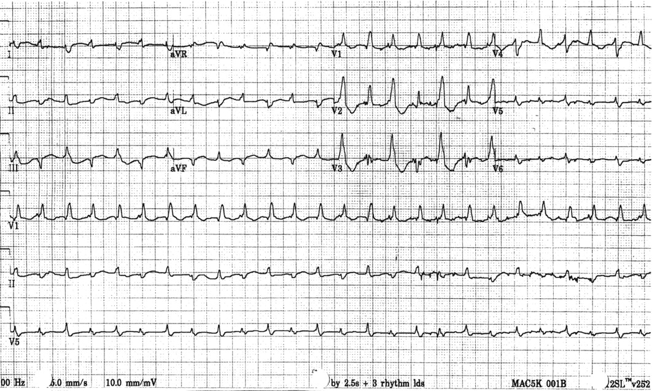

LABORATORY RESULTS

Hgb 118*
WBC 13.8*
Plt 468

Na 132
Cl 100*
K 5.1*
CO2 20*
Glucose 6.8
BUN 14.3*
Creat 210*

CK 131
Trop I 0.025

INR 1.9*
PTT 28

pH 7.32
pCO2 35
pO2 42 (venous)
HCO3 20

Lactate 2.3

LABORATORY RESULTS (Supplemental)

Digoxin 5.9* [1.0-2.6]

